**CS4225/CS5425 BIG DATA SYSTEMS FOR DATA SCIENCE**

Tutorial 4: Streaming and Graphs

1. In Spark Structured Streaming, why we need to specify a checkpoint location?

Answer:

2. In Spark Structured Streaming, we are using below codes to collect the streaming data from sensor readings.

From 12:05 to 12:10, we have received below events:

|  |  |
| --- | --- |
| **Event Table** | |
| **sensorID** | **Event Time** |
| id1 | 12:06 |
| id1 | 12:08 |

And at 12:10 the below result table is triggered:

|  |  |  |
| --- | --- | --- |
| **Result Table** | | |
| **Event Window** | **sensorID** | **Count** |
| 11:50-12:00 | id1 | 1 |
| 11:55-12:05 | id1 | 1 |
| 12:00-12:10 | id1 | 2 |
| 12:05-12:15 | id1 | 2 |

From 12:10 to 12:15, we received three more events per below:

|  |  |
| --- | --- |
| **Event Table** | |
| **sensorID** | **Event Time** |
| id1 | 11:54 |
| id1 | 12:02 |
| id1 | 12:13 |

Please provide the result table at 12:15.

|  |  |  |
| --- | --- | --- |
| **Result Table** | | |
| **Event Window** | **sensorID** | **Count** |
| 11:50-12:00 | id1 |  |
| 11:55-12:05 | id1 |  |
| 12:00-12:10 | id1 |  |
| 12:05-12:15 | id1 |  |
| 12:10-12:20 | id1 |  |
| 11:50-12:00 | id1 |  |

Answer:

**3.** Consider three Web pages with the following links:

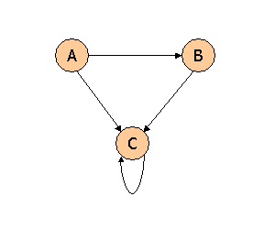

Suppose we compute PageRank with a β of 0.7 (note: we assume that the sum of the PageRanks of the three pages must be 1, to handle the problem that otherwise any multiple of a solution will also be a solution). Compute the PageRanks a, b, and c of the three pages A, B, and C, respectively.

Answer:

**4.** Consider three Web pages with the following links:

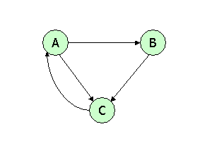

Suppose we compute PageRank with β=0.85. Write the equations for the PageRanks a, b, and c of the three pages A, B, and C, respectively.

Answer: